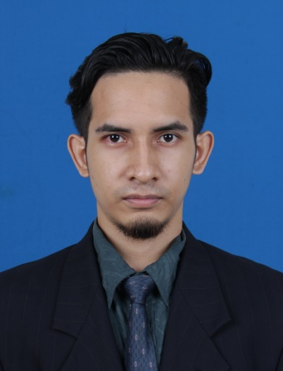**MOHAMMAD FAHTUL QAIZZ BIN HASBULLAH**

013-6459861

fahtul_qaizz@yahoo.com

Lot 426, Kampung Chepa, Kubang Kerian,

16150 Kota Bharu, Kelantan.

**1. EDUCATION**

**UNIVERSITI TEKNOLOGI MALAYSIA (UTM), KUALA LUMPUR**

* BACHELOR’S DEGREE OF ELECTRONIC SYSTEM ENGINEERING
* FACULTY OF MALAYSIA-JAPAN INSTITUTE OF TECHNOLOGY (MJIIT)
* CURRENT CGPA : 2.97/4.00
* GRADUATED ON OCTOBER 2016

**UNIVERSITI TEKNOLOGI MALAYSIA (UTM), KUALA LUMPUR**

* DIPLOMA OF ELECTRICAL ENGINEERING
* MAJOR IN MECHATRONIC
* CGPA : 3.18/4.00
* GRADUATED ON JULY 2013

**SEKOLAH MENENGAH TEKNIK BACHOK, KELANTAN**

* SIJIL PELAJARAN MALAYSIA (SPM)
* RESULTS : 6A’S 4B’S
* 2008/2009

**2. WORK EXPERIENCE**

**PETRONAS CHEMICALS ETHYLENE SDN BHD / PETRONAS CHEMICALS POLYETHYLENE SDN BHD, KERTEH, TERENGGANU**

* Industrial Trainee
* Maintenance Service Focusing On Instrumentation
* Instruments And Valves Installation In Plant
* Monitoring The Reading And Calibration
* Daily Tasks And Attended Daily Meeting Also Works In A Team
* Jun – September 2015

**MALAYSIA-JAPAN INSTITUTE OF TECHNOLOGY, UNIVERSITI TEKNOLOGI MALAYSIA,**

**KUALA LUMPUR**

* Laboratory Assistant
* Daily Maintenance For New Laboratory Assembly
* Doing Standard Operating Procedure (Sop) On New Equipment
* Work In A Group And Daily Meeting
* January – March 2014

**3. SKILLS**

**LANGUAGE SPOKEN WRITTEN**

* MALAY FLUENT FLUENT
* ENGLISH GOOD GOOD
* JAPANESE FAIR FAIR

**IT SKILLS**

* Microsoft Office Packages (Word, Excel, Powerpoint), Synopsys RSOFT BEAMPROP, AUTOCAD, Multisim, MATLAB, Verilog, PLC.

**4. ACHIEVEMENTS**

|  |  |  |
| --- | --- | --- |
| **DESCRIPTION** | **DATE ACHIEVED** | **DETAILS** |
| Kem Kecemerlangan Lukisan Kejuruteraan | 2009 | Facilitator |
| Electrical Work Assembly | 2010 | Participate |
| Persatuan Silat Cekak Utmkl | 2011 -2012 | Vice-President |
| Kejohanan Wajadiri Nasional Silat Cekak Hanafi | 2011- 2015 | Participate |
| Persatuan Silat Cekak Ustaz Hanafi Malaysia | 2013- 2014 | Trainer Level 1 |
| Safety And Health Induction For Construction Workers Course | 2013 | HIDEF Training And Consultancy, Participate |
| Head Of Department Award | 2014 | CGPA : 3.38 |
| Final Year Project | 2016 | Performance Evaluation Of Tapered Optical Fibre Coated With Graphene For Optical Sensor Application. |
| 2016 Best Photonics Engineering Project Award | 2016 | IEEE Photonics Society Malaysia Chapter, Final Year Project. |

**5. OTHERS**

* Possess Own Transport And Willing To Travel
* Driving License: B2 And D
* Member Of IEEE (Student)
* Member Of Photonics Society (IEEE)
* Available Anytime

**6. REFERENCES**

|  |  |  |
| --- | --- | --- |
| **NAME** | **DESIGNATION** | **CONTACT** |
| Dr Sumiaty Binti Ambran | FYP Supervisor / Senior Lecturer | +06 03 2203 1329  [sumiaty.kl@utm.my](mailto:sumiaty.kl@utm.my) |
| Muhammad Najmuddin Bin Abu Bakar | Industrial Training Supervisor / Executive | +06 012 384 9752  najmuddin.abakar@petronas.com.my |